RETURN TO YOUR PRAYER CLOSETS NOW!!! WARNING – URGENT!!!
December 20, 2016
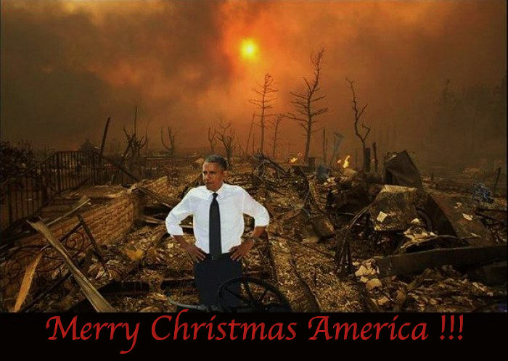
Well, my Heartdwellers, the Lord is calling us back to prayer during this window of grace. It's a very serious situation and I'm sorry I haven't been with you for a couple of days. There's been a change in employment and helpers around here, and I've been very tied up with it. And the Lord even chided me about it. I had to be forgiven for neglecting my duties with you.

So, He has a very urgent message today.

One thing I want to tell you is, Ezekiel is doing much better. For two days, when he came out of this offering, he was so filled with the Spirit and he was conversing freely with God the Father and going places with Him. And resting deeply in His heart. And there's some beautiful things to share there. But it's not what the Lord wanted me to share tonight. So, we'll get back to that.

He began, "It is truly wonderful how My Father has been working through your husband. Not only in fast offerings that truly seemed the blackest pit, which he weathered because he was not swimming on the surface, but deeply beneath all the turbulence. But tonight is not the night for such joyous experiences.

"Rather, we are still on the brink of war with Russia. Your president is still hell bent, literally, on destroying this country and not allowing President elect Trump to undo all the evil he so cleverly put in place to entrap the ignorant American people. He is not about to go down without a vicious fight and what you see in the media is nothing compared to what he’s planning behind closed doors.

"Heartdwellers…lest you be the victims of nuclear war and have to behold the charred remains of little children and their mothers - pray like you have never prayed before. What is coming is horrendous and must be stopped by your prayers.

"You see when I give a prophecy to My Body it is a “can be.” I am presenting you with the best possible scenario and what My heart truly desires for you. And along with that I am counting on you to intercede to make sure it happens.

"That is why I am making this urgent plea to NOT BE DISTRACTED by Christmas, because this is precisely what the enemy is counting on - that you be absent from your prayer closets. This is NOT the time to celebrate. This is the time to mourn and weep and pray as never before that this wicked man be stopped.

"You see My promise to you of three years more was conditional, and right now you are facing the conditions that will result in the worst tragedy this world has ever seen. Or the most wonderful victory. And it is in your hands.

"You see, if My plan fails, there will be an earlier rapture. But do not, do not, give up hope and let this go. We are on the verge of a wonderful overturning of the wicked powers of this world. And they know that it is your prayers that will cause it to happen. So they are counting on your Christmas shopping to distract you away from prayer so they can take full advantage of your momentary lapse.

"In years gone by, this has always been a sad time for Me because My people are busy about the world and I am left alone. There are very dark and clever spirits of distraction, false guilt and family gatherings that have gone to work and are diverting the prayers I need to stave off this war. I need these prayers. This IS what the enemy counted on, but I am begging you RETURN TO YOUR PRAYER CLOSETS, NOW! Do not delay another moment. If you have to get up earlier, go to bed earlier or sacrifice your sleep to pray - then do it.

"This is dire necessity. I want you to be victorious, so please heed My supplications as I heed yours when you are at the lowest and in dire straights, because that’s where I am right now.

"PLEASE, RETURN TO YOUR PRAYER CLOSETS and curtail your involvements with holiday plans. I am now sending angels to divert family events that would entrap you, right now. They are coming to you. Do not allow the enemy to slam you with false guilt.Let your plans fall into the hands of those who are not praying and RETURN TO THE PRAYER CLOSET. NOW!!

“I love you. please, let’s not lose this battle. Please.”

And that's the end of His message. And I know I've been guilty of distractions because of the changes here with assistance. I, too, am being called back to the prayer closet and to curtail even trying to set things up and get things running smoothly again. I'm having to back off on that, to get more deeply into prayer.

So please, Heartdwellers, heed the urgent call of our Lord. The enemy is counting on us to be distracted by the pretty lights and the fine foods and the family gatherings and comforts. Don't let it happen. Don't be pulled off course. Allow others to take the burden off of you and do as much as you can in prayer to stop this war from taking place. Because Obama has failed all the other stop-gap measures. And now he's facing the Button. Please - don't let him press that button!

And for those of you who have been praying for us, thank you. We're coming out of a very dark time and beginning to run much more smoothly. And we'll have an announcement of a book pretty soon that's published and will be for sale at Amazon. The Rhema book. It's not quite there yet, but almost. And pray for me. I'm trying to finish the portrait. Everything is done but His shirt. So, please pray also that I'll be able to finish His shirt. And then I'll have some high-quality photographs, digital images, that you'll be able to print into portraits. But please, don't sacrifice your time in the prayer closet for this.

Just a head's up, don't let the day after Christmas be a day that you skip prayer.

The Lord bless you, Heartdwellers. Thank you so much for being so supportive of our channel. Truly, you're the greatest blessing in our lives.

